301: DATA INTELLIGENCE AND VISUALIZATION

UNIT 3: DATA TRANSFORMATION, QUERY SETTINGS & DATA SHAPING

PRACTICAL LAB MANUAL
Dataset: PowerBI_Student_Practice_Dataset.xlsx

INDEX
Sr. No. | Practical No. | Practical Title | Dataset Used | Page No.
1 | 3.1.1 | Formatting and Transformation of Data | 1_Students_Raw
2 | 3.1.2 | Understanding and Changing Data Types | 1_Students_Raw
3 | 3.1.3 | Data Profiling for Data Quality Check | 1_Students_Raw
4 | 3.1.4 | Merge, Append and Group By Queries | 1_Students_Raw, 2_Students_Batch2, 3_Courses_Lookup, 6_Fee_Transactions
5 | 3.2.1 | Duplicate and Reference Tables | 1_Students_Raw
6 | 3.2.2 | Transpose of Data | 7_Dept_Budget_Matrix
7 | 3.2.3 | Pivot and Unpivot of Data | 4_Attendance_Wide, 5_Marks_Long
8 | 3.2.4 | Custom and Conditional Columns | 1_Students_Raw
9 | 3.2.5 | Replacing Data from Tables | 1_Students_Raw
10 | 3.2.6 | Splitting Column Values | 1_Students_Raw
11 | 3.3.1 | Detect Data Type, Count Rows, Reverse Rows and Sorting | 8_Raw_Export_NoHeader
12 | 3.3.2 | Promoting Rows as Column Headers | 8_Raw_Export_NoHeader
13 | 3.3.3 | Creating Hierarchies in Power BI | 9_Geo_Hierarchy
14 | 3.3.4 | Understanding and Working with M Query | 1_Students_Raw / Any Query
15 | P-15 | Complete Student Data Cleaning and Transformation | 1_Students_Raw
16 | P-16 | Merge Student and Course Information | 1_Students_Raw, 3_Courses_Lookup
17 | P-17 | Creating a Matrix Visual with Course and Campus Analysis | Student/Course Data + 9_Geo_Hierarchy
18 | P-18 | Integrated Data Transformation, Shaping and Visualization | Complete Dataset

Practical 1: Formatting and Transformation of Data
Dataset: 1_Students_Raw
Perform the following operations in Power Query Editor:
- Load the 1_Students_Raw table.
- Remove leading and trailing spaces from the Full_Name column.
- Convert Full_Name into Capitalize Each Word format.
- Convert all values in the Email column to lowercase.
- Trim the Course column.
- Standardize inconsistent course values.
- Remove currency symbols and commas from Fees_Paid.
- Convert Fees_Paid to Whole Number.
- Rename the query as Students_Cleaned.
- Apply the transformations and load the cleaned data.
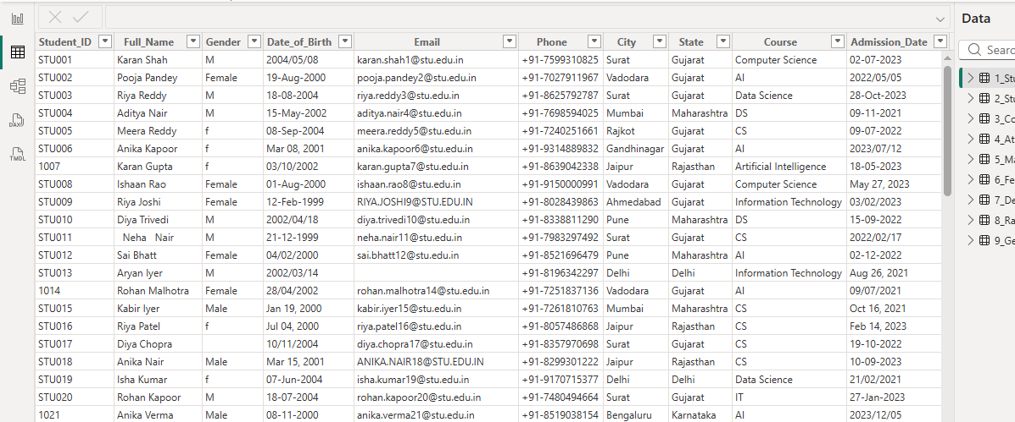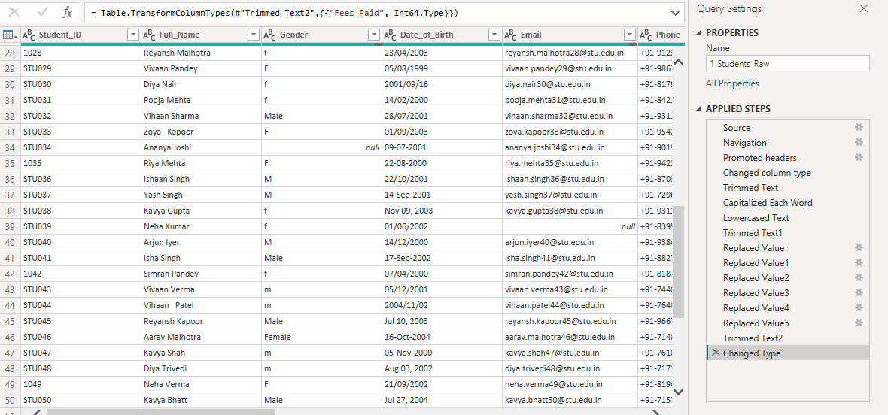

Practical 2: Understanding and Changing Data Types
Dataset: 1_Students_Raw
Perform the following operations:
- Identify the existing data type of each column.
- Change Student_ID to Text.
- Convert Date_of_Birth to Date.
- Convert Admission_Date to Date.
- Clean invalid CGPA values.
- Convert CGPA to Decimal Number.
- Remove the % symbol from Attendance_Percent.
- Convert Attendance_Percent to an appropriate numeric/percentage type.
- Identify any errors generated during conversion.
- Correct the errors and verify the final data types.
Expected Output: A table in which all columns have appropriate data types.

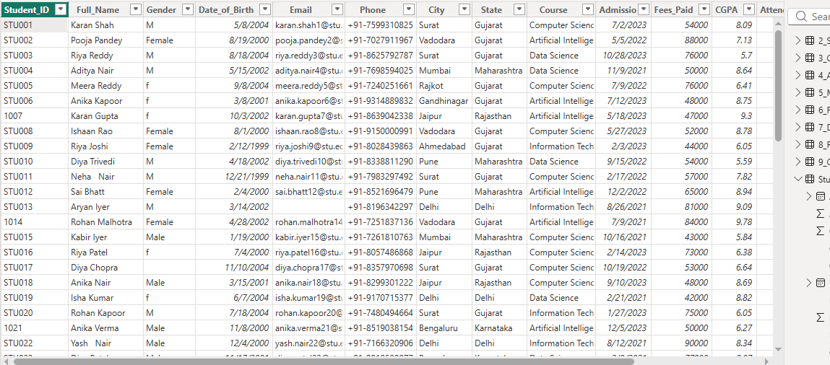
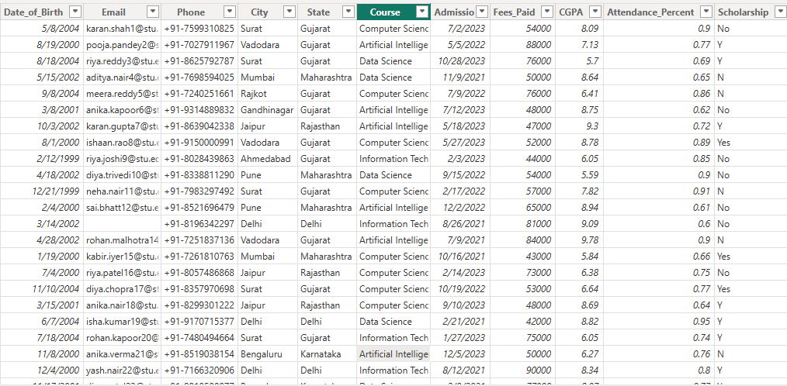

Practical 3: Data Profiling for Data Quality Check
Dataset: 1_Students_Raw
Perform the following:
- Load the dataset into Power Query Editor.
- Open the View tab.
- Enable Column Quality.
- Enable Column Distribution.
- Enable Column Profile.
- Analyze the Gender column.
- Identify inconsistent Gender values.
- Analyze the Email column and identify blank values.
- Analyze the CGPA column for errors and invalid values.
- Filter the table to display error rows.
- Correct the identified data-quality problems.
- Recheck the profiling information.
Expected Output: A data-quality-checked student table.
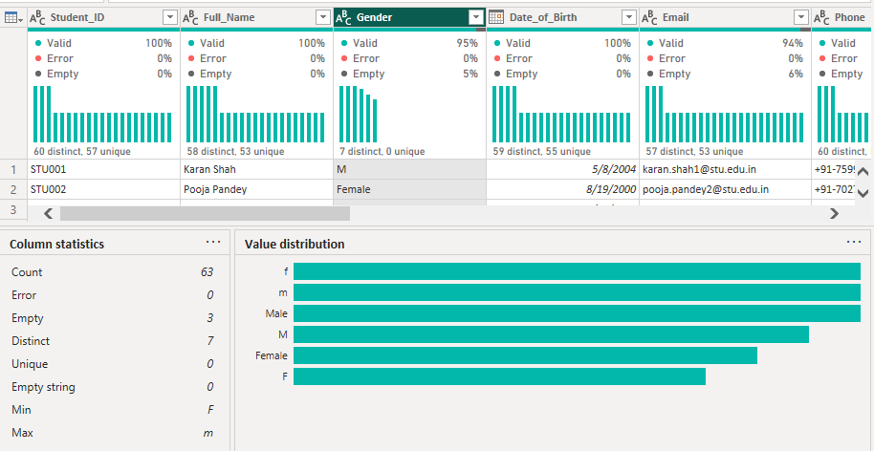
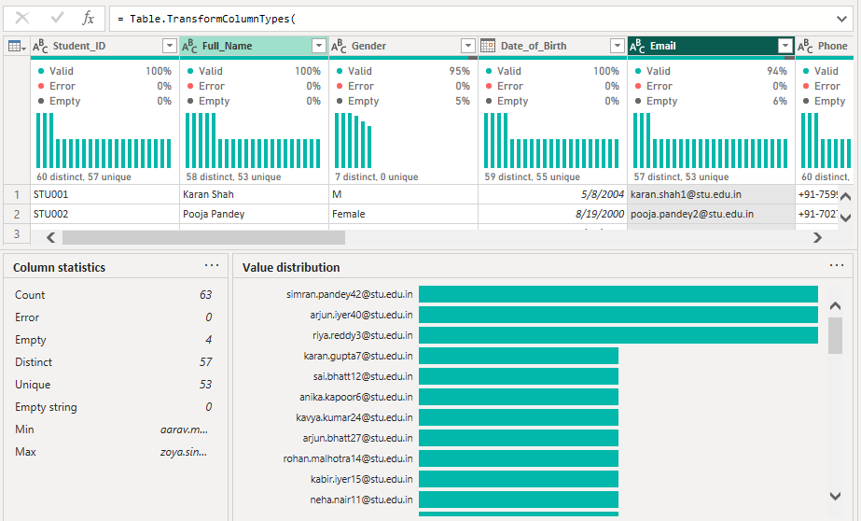
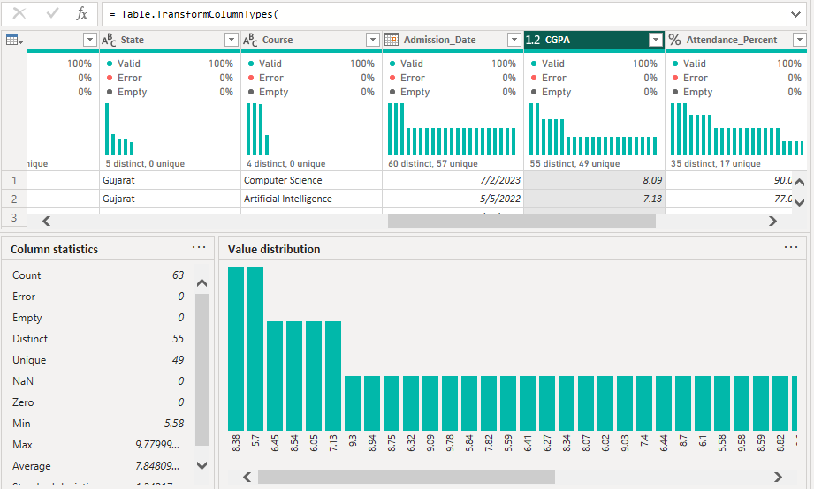

Practical 4: Merge, Append and Group By Queries
Datasets: 1_Students_Raw, 2_Students_Batch2, 3_Courses_Lookup, 6_Fee_Transactions
Perform the following three operations:

A. Merge Query
- Load 1_Students_Raw and 3_Courses_Lookup.
- Select 1_Students_Raw.
- Choose Home → Merge Queries.
- Match Course with Course_Code.
- Select Left Outer Join.
- Expand Course_Full_Name.
- Expand Department.
- Expand Fees_Per_Semester
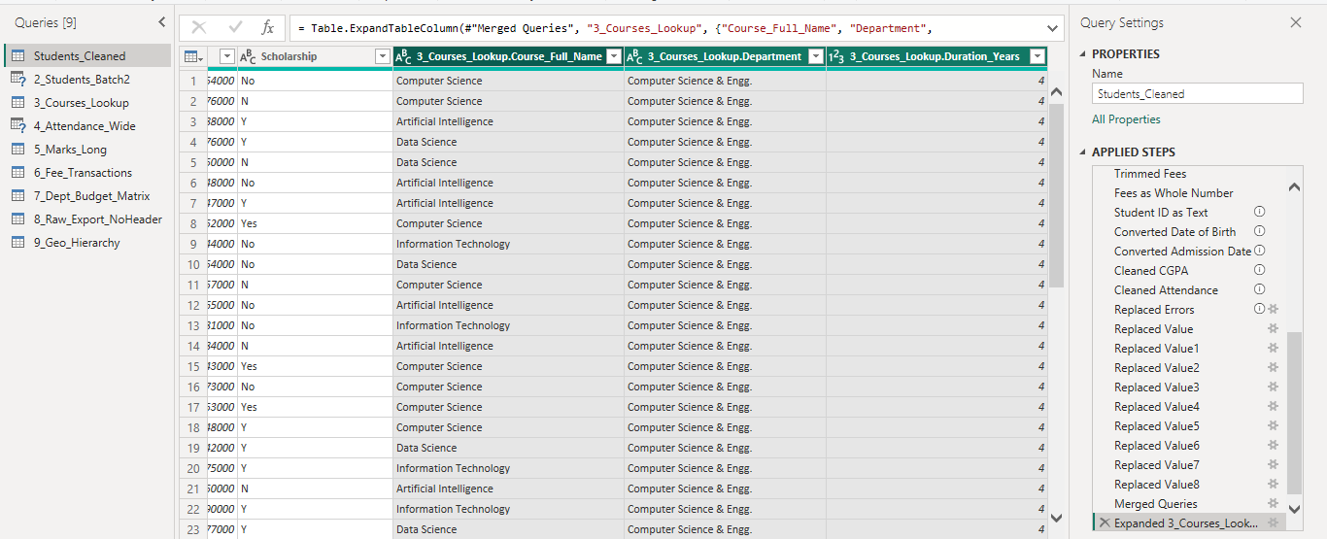

B. Append Query
- Load 1_Students_Raw and 2_Students_Batch2.
- Select Home → Append Queries → Append Queries as New.
- Select both student tables.
- Verify the total number of student records.
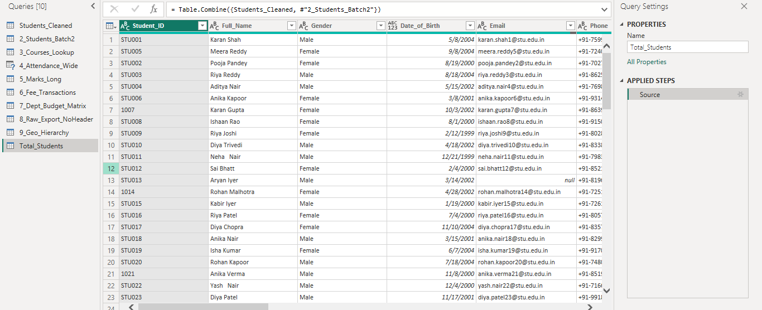

C. Group By
- Load 6_Fee_Transactions.
- Select Home → Group By.
- Group the data by Student_ID.
- Create Total_Fees_Paid using Sum of Amount.
- Create Transaction_Count using Count Rows.
- Apply the Group By operation.
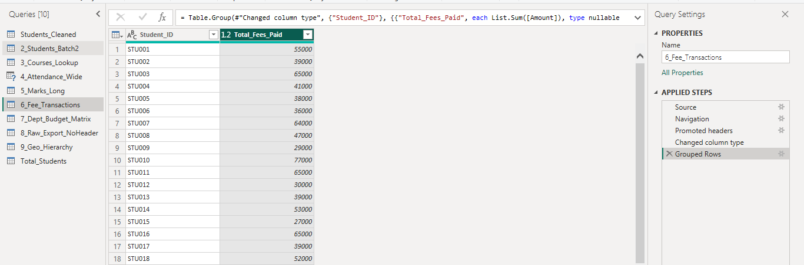
Expected Output: Merged course information, combined student records and student-wise fee summary.

Practical 5: Duplicate and Reference Tables
Dataset: 1_Students_Raw

Duplicate Query
- Right-click 1_Students_Raw.
- Select Duplicate.
- Rename the query as Students_Raw_Copy.
- Compare its Applied Steps with the original query.
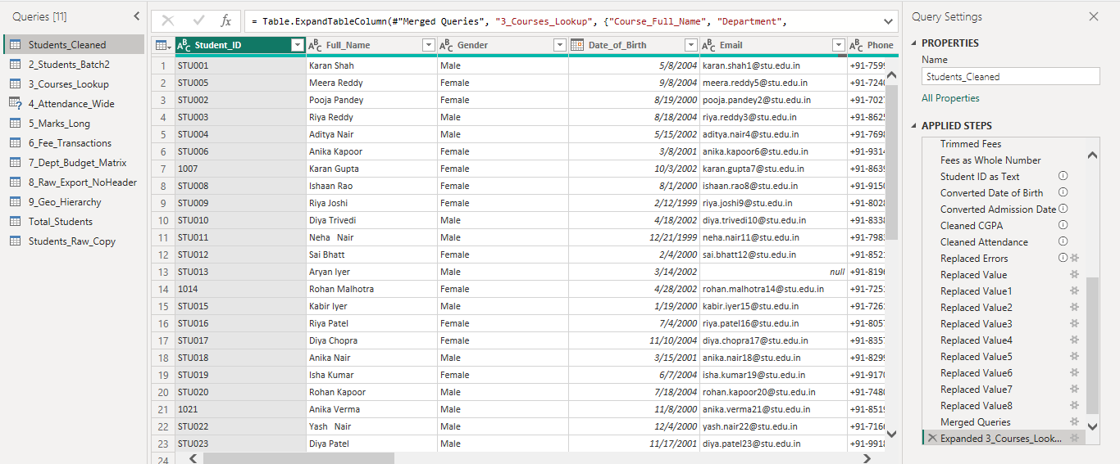
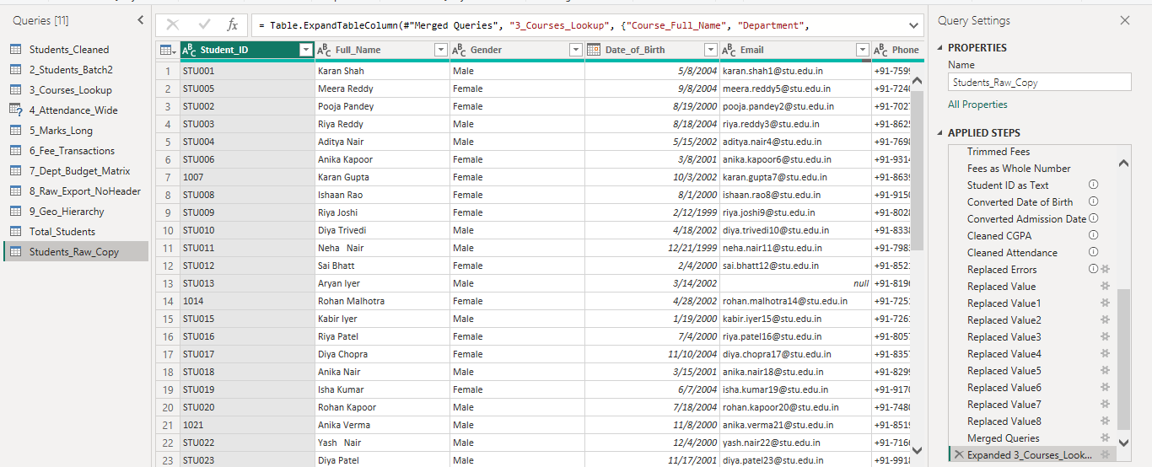

Reference Query
- Right-click 1_Students_Raw.
- Select Reference.
- Rename the query as Students_Summary.
- Apply Group By on Course.
- Count the number of students in each course.
- Modify the original query.
- Observe the effect on the Reference Query.
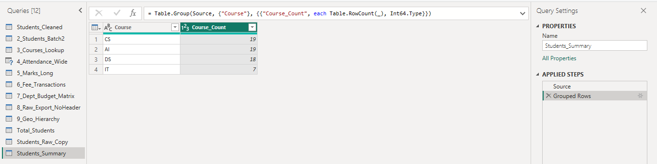
Expected Output: An independent duplicate query and a dependent reference query.

Practical 6: Transpose of Data
Dataset: 7_Dept_Budget_Matrix
Perform the following:
- Load the dataset into Power Query.
- Examine the original wide-format structure.
- Select Transform → Transpose.
- Transpose the table.
- Promote the appropriate row as column headers.
- Rename the required column as Department.
- Verify the resulting table structure.
- Apply the changes.
Expected Output: A transformed table in which rows and columns are interchanged.
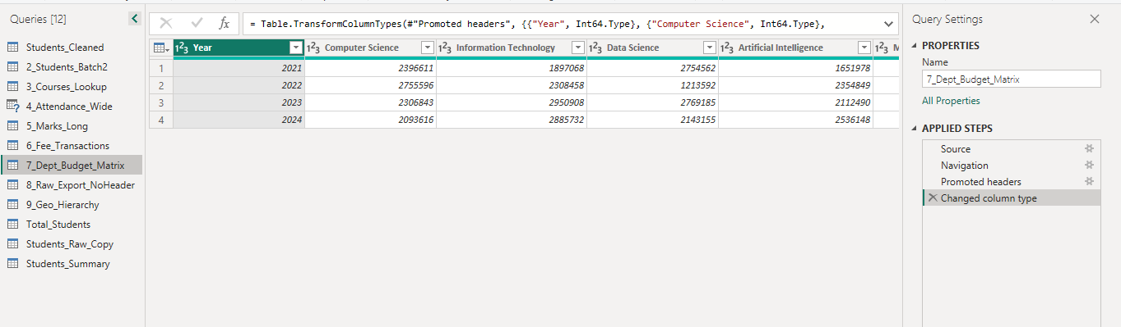
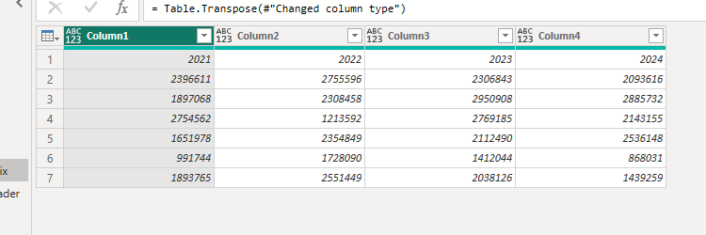
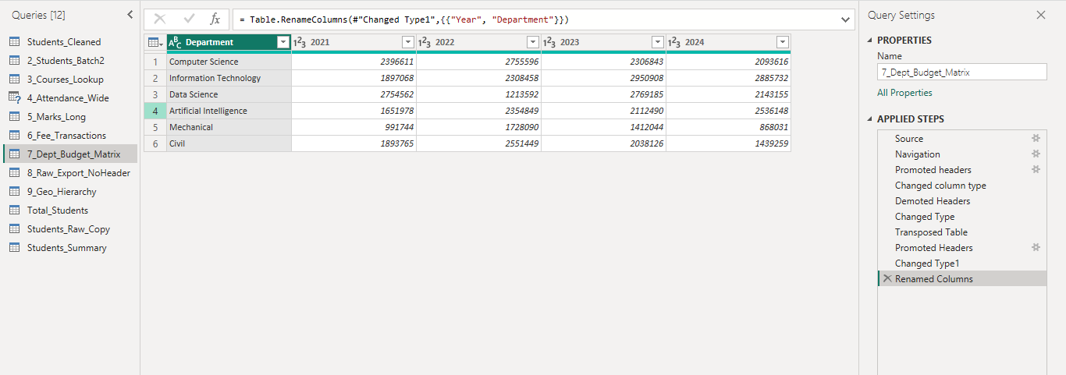

Practical 7: Pivot and Unpivot of Data
Datasets: 4_Attendance_Wide, 5_Marks_Long

A. Unpivot Attendance Data
- Load 4_Attendance_Wide.
- Select the Student_ID column.
- Select Transform → Unpivot Columns → Unpivot Other Columns.
- Rename Attribute to Month.
- Rename Value to Attendance_Percent.
- Verify the number of rows before and after transformation.
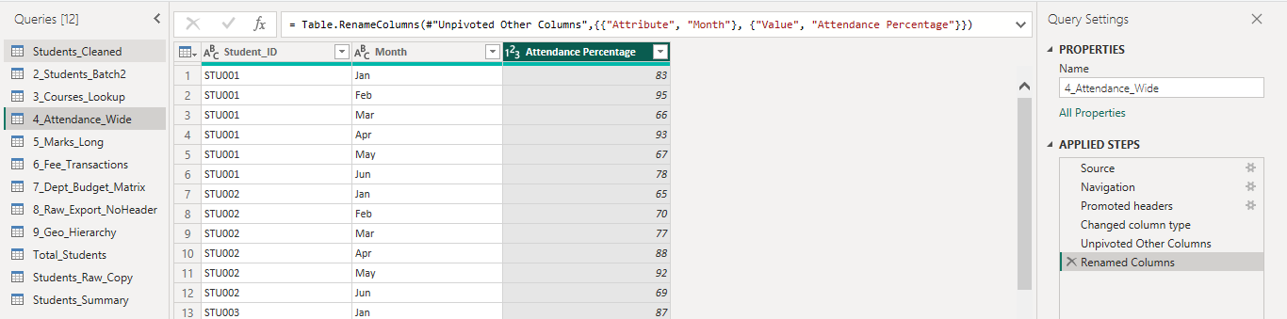

B. Pivot Marks Data
- Load 5_Marks_Long.
- Select the Subject column.
- Select Transform → Pivot Column.
- Select Marks as the Values Column.
- Select Don't Aggregate where appropriate.
- Apply the transformation.
- Verify that each subject appears as a separate column.
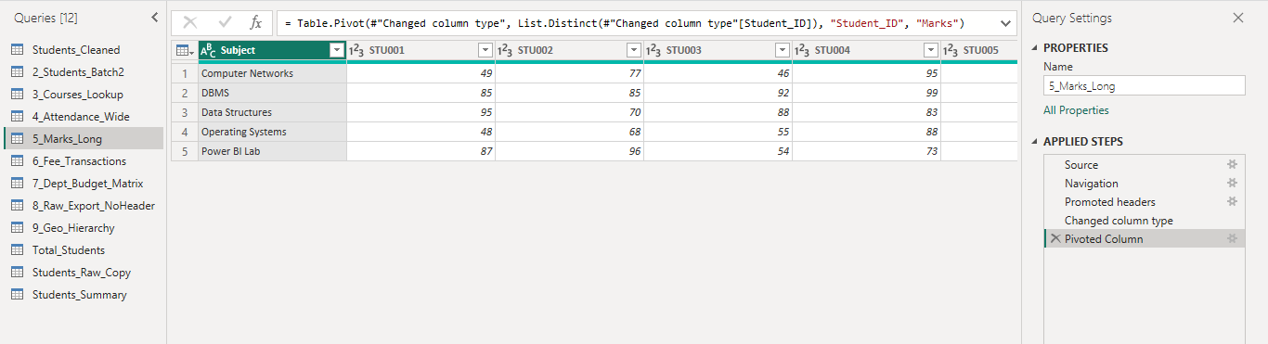
Expected Output: A long-format attendance table and a report-card-style marks table.

Practical 8: Custom and Conditional Columns

A. Custom Columns
- Create a Custom Column named Full_Contact_Info.
- Combine Full_Name and Email into this column.
- Create another Custom Column named Admission_Year.
- Extract the year from Admission_Date.

B. Conditional Columns
- Create a Conditional Column named CGPA_Grade.
- Apply the following conditions:
Condition | Grade
CGPA ≥ 9 | A+
CGPA ≥ 8 | A
CGPA ≥ 7 | B
Otherwise | C
- Create another Conditional Column named Attendance_Flag.
- Apply the following conditions:
Condition | Result
Attendance < 75 | Shortage
Attendance ≥ 75 | Eligible

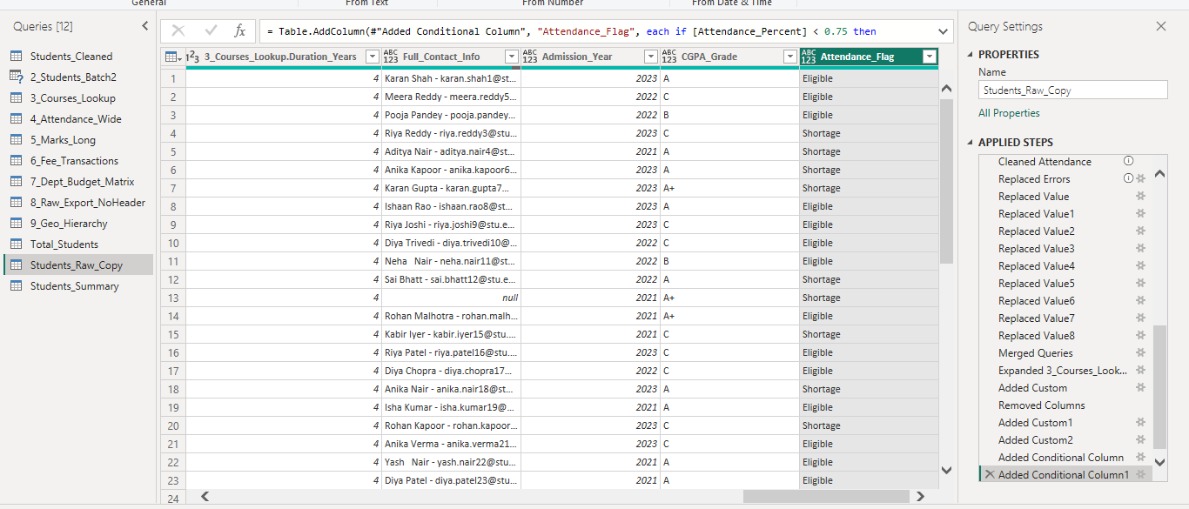

Practical 9: Replacing Data from Tables
Dataset: 1_Students_Raw
Perform the following replacements:

Gender
- Replace Male with M.
- Replace Female with F.
- Replace m with M.
- Replace f with F.

Course
- Replace Computer Science with CS.
- Replace Information Technology with IT.
- Replace Data Science with DS.
- Replace Artificial Intelligence with AI.

Fees
Remove:
- Rs.
- ₹
- commas

Attendance
Remove the % symbol.
Finally, verify that the values have been standardized.
Expected Output: A cleaned table containing standardized Gender, Course, Fees and Attendance values.
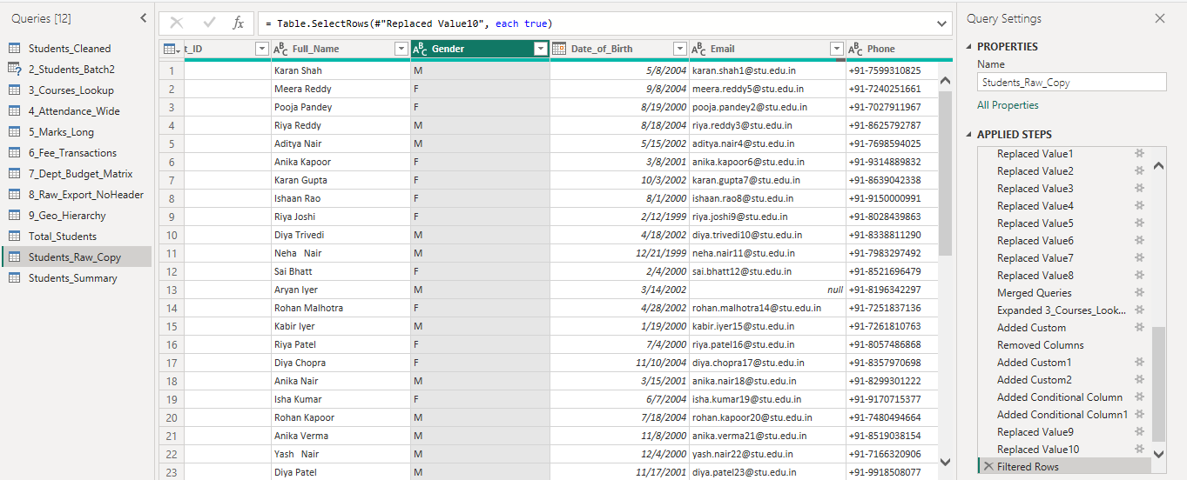
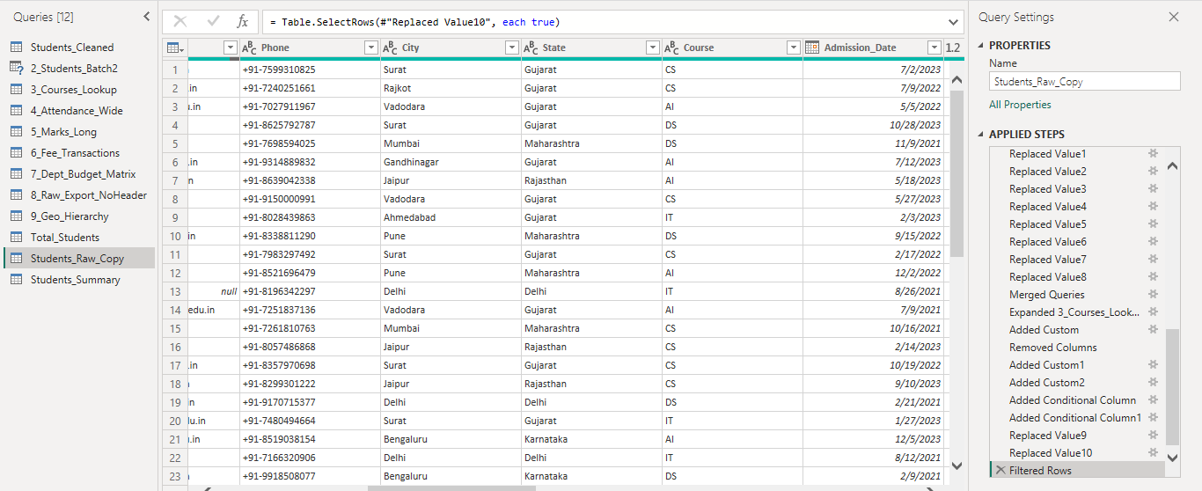
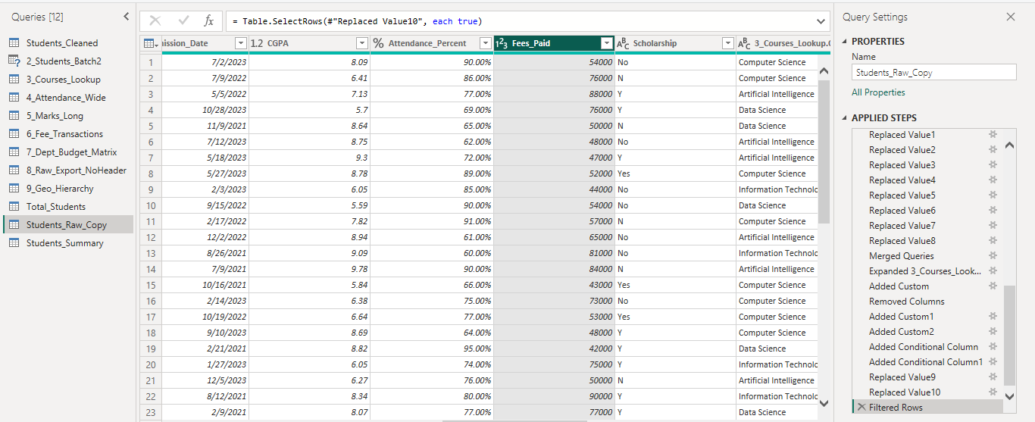

Practical 10: Splitting Column Values
Dataset: 1_Students_Raw
Perform the following:
- Select the Full_Name column.
- Select Split Column → By Delimiter.
- Select Space as the delimiter.
- Split at the left-most delimiter.
- Rename the resulting columns First_Name and Last_Name.
- Select the Phone column.
- Split the column using - as the delimiter.
- Rename the resulting columns Country_Code and Phone_Number.
- Identify CGPA values containing text such as 8.6 out of 10.
- Split the CGPA column using Space as the delimiter.
- Keep the numeric portion.
- Convert the resulting CGPA column to Decimal Number.
Expected Output: Separate columns for name, country code, phone number and cleaned CGPA.
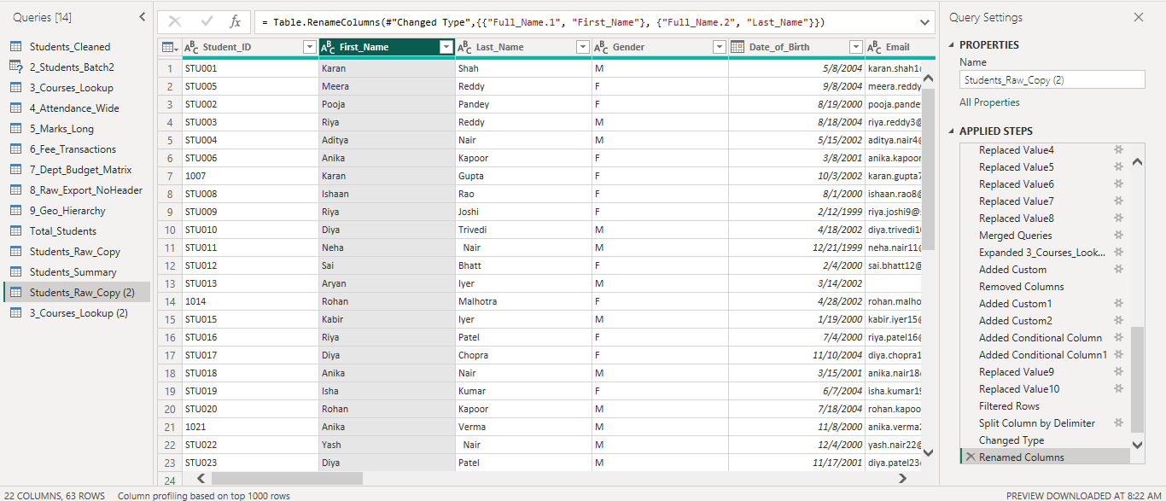
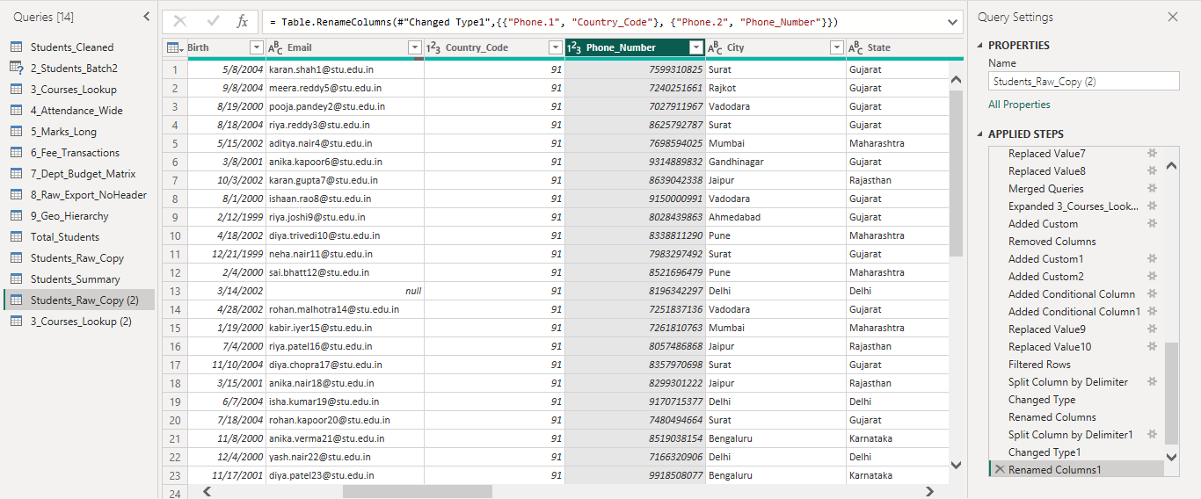

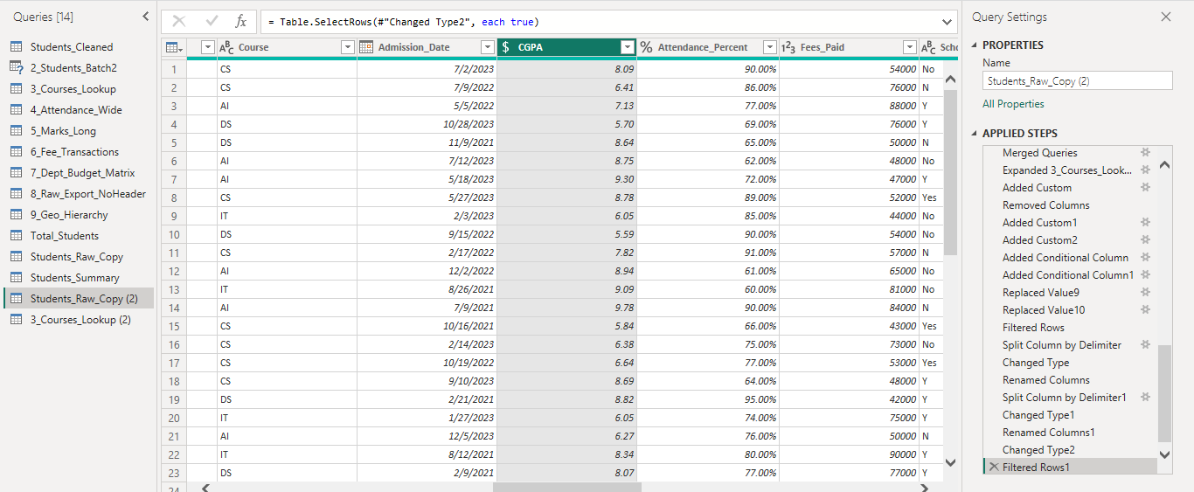

Practical 11: Detect Data Type, Count Rows, Reverse Rows and Sorting
Dataset: 8_Raw_Export_NoHeader
Perform the following:
- Load the raw placement dataset.
- Remove the unwanted rows.
- Promote the correct row as headers.
- Use Detect Data Type.
- Verify the data type of each column.
- Create a Reference Query named Placement_Row_Count.
- Use Count Rows to find the total number of placement records.
- Return to the original query.
- Apply Reverse Rows.
- Sort Placement_Date in ascending order.
- Sort Placement_Date in descending order.
- Compare the results.
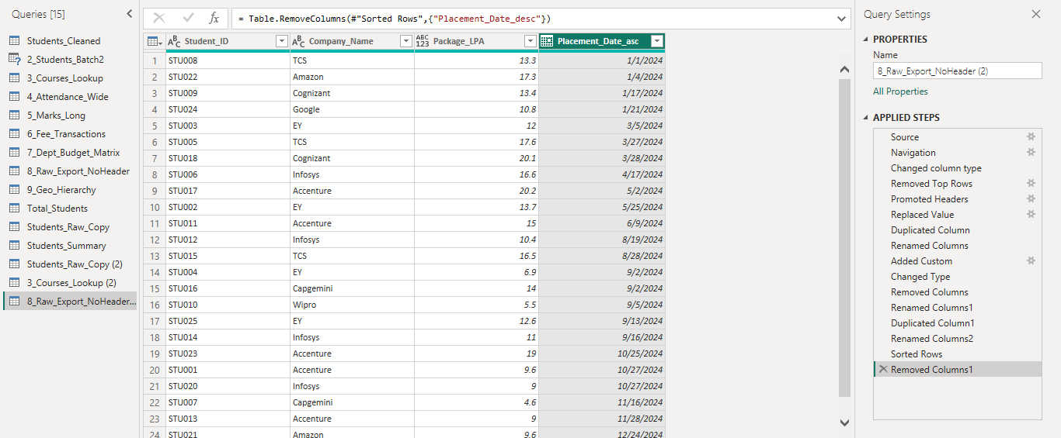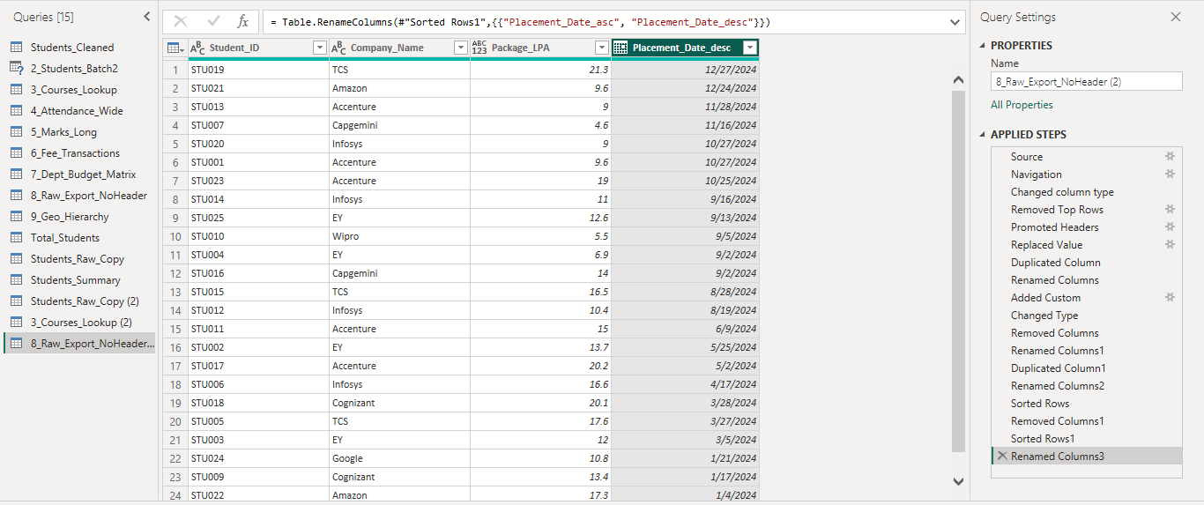

Practical 12: Promoting Rows as Column Headers
Dataset: 8_Raw_Export_NoHeader
Perform the following:
- Load the raw placement report.
- Identify the unwanted title and metadata rows.
- Remove the first two rows.
- Select Home → Use First Row as Headers.
- Verify the following column names:
- Student_ID
- Company_Name
- Package_LPA
- Placement_Date
- Apply appropriate data types to all columns.
Expected Output: A properly structured placement table with correct column headers.
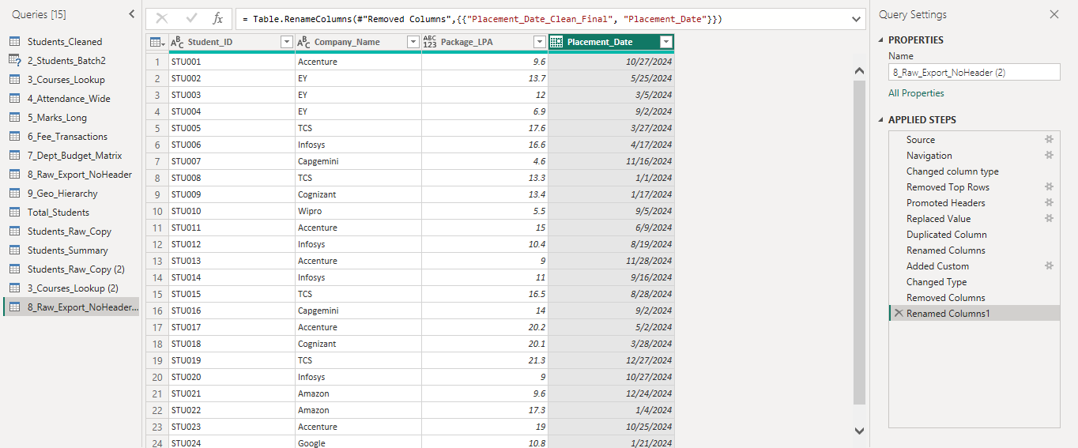

Practical 13: Creating Hierarchies in Power BI
Dataset: 9_Geo_Hierarchy
Perform the following:
- Load 9_Geo_Hierarchy into Power BI.
- Go to Report or Model view.
- Right-click the Country field.
- Select Create Hierarchy.
- Add State to the hierarchy.
- Add City.
- Add Campus.
- Rename the hierarchy as Geo_Hierarchy.
- Create a Matrix visual.
- Add Geo_Hierarchy to the Rows section.
- Add Students_Enrolled to Values.
- Demonstrate drill-down from:
Country → State → City → Campus
Expected Output: A Matrix visual with an interactive geographical hierarchy.

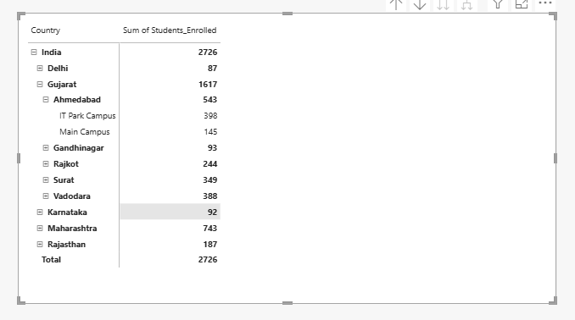

Practical 14: Understanding and Working with M Query
Dataset: 1_Students_Raw / Any Query
Perform the following:
- Open a query in Power Query Editor.
- Select View → Advanced Editor.
- Identify the let...in structure.
- Identify the individual Applied Steps in the M code.
- Identify the M code for a transformation such as Trim or Rename.
- Create a Custom Column.
- Open Advanced Editor again.
- Locate the Table.AddColumn() function.
- Explain each M step in plain English.
- Make one simple modification to an M step.
- Verify the result.
Expected Output: An M Query with an explanation of the major transformation steps.
M- Query:
let
Source = Excel.Workbook(File.Contents("C:\Users\Dell\Downloads\PowerBI_Student_Practice_Dataset.xlsx"), null, true),
#"Navigation 1" = Source{[Item="1_Students_Raw", Kind="Sheet"]}[Data],
#"Promoted headers" = Table.PromoteHeaders(#"Navigation 1", [PromoteAllScalars=true]),
#"Initial Data Types" = Table.TransformColumnTypes(#"Promoted headers", {{"Student_ID", type text}, {"Full_Name", type text}, {"Gender", type text}, {"Date_of_Birth", type text}, {"Email", type text}, {"Phone", type text}, {"City", type text}, {"State", type text}, {"Course", type text}, {"Admission_Date", type text}, {"Fees_Paid", type text}, {"Attendance_Percent", type text}, {"Scholarship", type text}, {"CGPA", type text}}),
#"Trimmed Full Name" = Table.TransformColumns(#"Initial Data Types", {{"Full_Name", Text.Trim, type text}}),
#"Capitalized Full Name" = Table.TransformColumns(#"Trimmed Full Name", {{"Full_Name", Text.Proper, type text}}),
#"Lowercased Email" = Table.TransformColumns(#"Capitalized Full Name", {{"Email", Text.Lower, type text}}),
#"Trimmed Course" = Table.TransformColumns(#"Lowercased Email", {{"Course", Text.Trim, type text}}),
#"Standardized CS" = Table.ReplaceValue(#"Trimmed Course", "CS", "Computer Science", Replacer.ReplaceText, {"Course"}),
#"Standardized AI" = Table.ReplaceValue(#"Standardized CS", "AI", "Artificial Intelligence", Replacer.ReplaceText, {"Course"}),
#"Standardized DS" = Table.ReplaceValue(#"Standardized AI", "DS", "Data Science", Replacer.ReplaceText, {"Course"}),
#"Standardized IT" = Table.ReplaceValue(#"Standardized DS", "IT", "Information Technology", Replacer.ReplaceText, {"Course"}),
#"Removed Rs" = Table.ReplaceValue(#"Standardized IT", "Rs.", "", Replacer.ReplaceText, {"Fees_Paid"}),
#"Removed Rupee Symbol" = Table.ReplaceValue(#"Removed Rs", "₹", "", Replacer.ReplaceText, {"Fees_Paid"}),
#"Removed Fee Commas" = Table.ReplaceValue(#"Removed Rupee Symbol", ",", "", Replacer.ReplaceText, {"Fees_Paid"}),
#"Trimmed Fees" = Table.TransformColumns(#"Removed Fee Commas", {{"Fees_Paid", Text.Trim, type text}}),
#"Fees as Whole Number" = Table.TransformColumnTypes(#"Trimmed Fees", {{"Fees_Paid", Int64.Type}}),
#"Student ID as Text" = Table.TransformColumnTypes(#"Fees as Whole Number", {{"Student_ID", type text}}),
#"Converted Date of Birth" = Table.TransformColumns(#"Student ID as Text", {{"Date_of_Birth", each try Date.FromText(Text.Trim(Text.From(_)), [Culture="en-GB"]) otherwise try Date.FromText(Text.Trim(Text.From(_)), [Culture="en-US"]) otherwise null, type date}}),
#"Converted Admission Date" = Table.TransformColumns(#"Converted Date of Birth", {{"Admission_Date", each try Date.FromText(Text.Trim(Text.From(_)), [Culture="en-GB"]) otherwise try Date.FromText(Text.Trim(Text.From(_)), [Culture="en-US"]) otherwise null, type date}}),
#"Cleaned CGPA" = Table.TransformColumns(#"Converted Admission Date", {{"CGPA", each try Number.FromText(Text.BeforeDelimiter(Text.Trim(Text.From(_)) & " ", " ")) otherwise null, type number}}),
#"Cleaned Attendance" = Table.TransformColumns(#"Cleaned CGPA", {{"Attendance_Percent", each let n = try Number.FromText(Text.Replace(Text.Trim(Text.From(_)), "%", "")) otherwise null in if n <> null then n / 100 else null, Percentage.Type}}),
#"Replaced Errors" = Table.ReplaceErrorValues(#"Cleaned Attendance", {{"Date_of_Birth", null}, {"Admission_Date", null}, {"CGPA", null}, {"Attendance_Percent", null}, {"Fees_Paid", null}}),
#"Replaced Value" = Table.ReplaceValue(#"Replaced Errors", "f", "Female", Replacer.ReplaceValue, {"Gender"}),
#"Replaced Value1" = Table.ReplaceValue(#"Replaced Value", "m", "Male", Replacer.ReplaceValue, {"Gender"}),
#"Replaced Value2" = Table.ReplaceValue(#"Replaced Value1", "M", "Male", Replacer.ReplaceValue, {"Gender"}),
#"Replaced Value3" = Table.ReplaceValue(#"Replaced Value2", "F", "Female", Replacer.ReplaceValue, {"Gender"}),
#"Replaced Value4" = Table.ReplaceValue(#"Replaced Value3", null, "Female", Replacer.ReplaceValue, {"Gender"}),
#"Replaced Value5" = Table.ReplaceValue(#"Replaced Value4", "Data Science", "DS", Replacer.ReplaceText, {"Course"}),
#"Replaced Value6" = Table.ReplaceValue(#"Replaced Value5", "Computer Science", "CS", Replacer.ReplaceText, {"Course"}),
#"Replaced Value7" = Table.ReplaceValue(#"Replaced Value6", "Artificial Intelligence", "AI", Replacer.ReplaceText, {"Course"}),
#"Replaced Value8" = Table.ReplaceValue(#"Replaced Value7", "Information Technology", "IT", Replacer.ReplaceText, {"Course"}),
#"Merged Queries" = Table.NestedJoin(#"Replaced Value8", {"Course"}, #"3_Courses_Lookup (2)", {"Course_Code"}, "3_Courses_Lookup", JoinKind.LeftOuter),
#"Expanded 3_Courses_Lookup" = Table.ExpandTableColumn(#"Merged Queries", "3_Courses_Lookup", {"Course_Full_Name", "Department", "Duration_Years"}, {"Course_Full_Name", "Department", "Duration_Years"}),
#"Added Custom1" = Table.AddColumn(#"Expanded 3_Courses_Lookup", "Full_Contact_Info", each [Full_Name] & " - " & [Email], type text),
#"Added Custom2" = Table.AddColumn(#"Added Custom1", "Admission_Year", each Date.Year([Admission_Date]), Int64.Type),
#"Added Conditional Column" = Table.AddColumn(#"Added Custom2", "CGPA_Grade", each if [CGPA] >= 9 then "A+" else if [CGPA] >= 8 then "A" else if [CGPA] >= 7 then "B" else "C", type text),
#"Added Conditional Column1" = Table.AddColumn(#"Added Conditional Column", "Attendance_Flag", each if [Attendance_Percent] < 0.75 then "Shortage" else "Eligible", type text),
#"Replaced Value9" = Table.ReplaceValue(#"Added Conditional Column1", "Male", "M", Replacer.ReplaceText, {"Gender"}),
#"Replaced Value10" = Table.ReplaceValue(#"Replaced Value9", "Female", "F", Replacer.ReplaceText, {"Gender"}),
#"Filtered Rows" = Table.SelectRows(#"Replaced Value10", each true),
#"Split Column by Delimiter" = Table.SplitColumn(#"Filtered Rows", "Full_Name", Splitter.SplitTextByEachDelimiter({" "}, QuoteStyle.Csv, false), {"Full_Name.1", "Full_Name.2"}),
#"Changed Type" = Table.TransformColumnTypes(#"Split Column by Delimiter", {{"Full_Name.1", type text}, {"Full_Name.2", type text}}),
#"Renamed Columns" = Table.RenameColumns(#"Changed Type", {{"Full_Name.1", "First_Name"}, {"Full_Name.2", "Last_Name"}}),
#"Split Column by Delimiter1" = Table.SplitColumn(#"Renamed Columns", "Phone", Splitter.SplitTextByEachDelimiter({"-"}, QuoteStyle.Csv, false), {"Phone.1", "Phone.2"}),
#"Changed Type1" = Table.TransformColumnTypes(#"Split Column by Delimiter1", {{"Phone.1", Int64.Type}, {"Phone.2", Int64.Type}}),
#"Renamed Columns1" = Table.RenameColumns(#"Changed Type1", {{"Phone.1", "Country_Code"}, {"Phone.2", "Phone_Number"}}),
#"Changed Type2" = Table.TransformColumnTypes(#"Renamed Columns1", {{"CGPA", Currency.Type}}),
#"Filtered Rows1" = Table.SelectRows(#"Changed Type2", each true)
in
#"Filtered Rows1"
Steps in simple english:
- Open Power Query Editor and select 1_Students_Raw.
- Open View → Advanced Editor.
- Identify the let...in structure in the M query.
- Identify the Source step that loads the Excel file.
- Identify the Navigation step that selects the 1_Students_Raw sheet.
- Identify the Promoted Headers step that makes the first row column headers.
- Identify the Initial Data Types step that sets the data types of columns.
- Identify the Trim step that removes extra spaces from Full_Name.
- Identify the Proper Case step that formats Full_Name.
- Identify the Lowercase step that converts Email to lowercase.
- Identify the Replace Value steps that standardize course names and clean fee values.
- Identify the Date conversion steps for Date_of_Birth and Admission_Date.
- Identify the CGPA and Attendance cleaning steps.
- Identify the Merge Queries step that combines student data with the course lookup table.
- Identify the Table.AddColumn() function used to create Full_Contact_Info.
- Identify the Table.AddColumn() function used to create Admission_Year.
- Identify the Conditional Column steps used to create CGPA_Grade and Attendance_Flag.
- Identify the Split Column steps used to split Full_Name and Phone.
- Identify the Rename Columns steps used to rename the split columns.
- Identify the in statement, which returns the final step Filtered Rows1.
- Make one simple modification to an M step, such as changing the separator in Full_Contact_Info.
- Click Done and verify that the modified result appears correctly in the table.

Practical 15: Complete Student Data Cleaning and Transformation
Dataset: 1_Students_Raw
Perform a complete data-cleaning workflow:
- Load the student dataset.
- Clean text fields.
- Standardize Gender values.
- Standardize Course values.
- Clean Fees_Paid.
- Correct all data types.
- Perform data profiling.
- Identify and correct errors.
- Create CGPA_Grade.
- Create Attendance_Flag.
- Verify the final cleaned student table.
- Load the transformed table into Power BI.
- Take a screenshot of the completed table.
Expected Output: A complete, clean and analysis-ready student table.
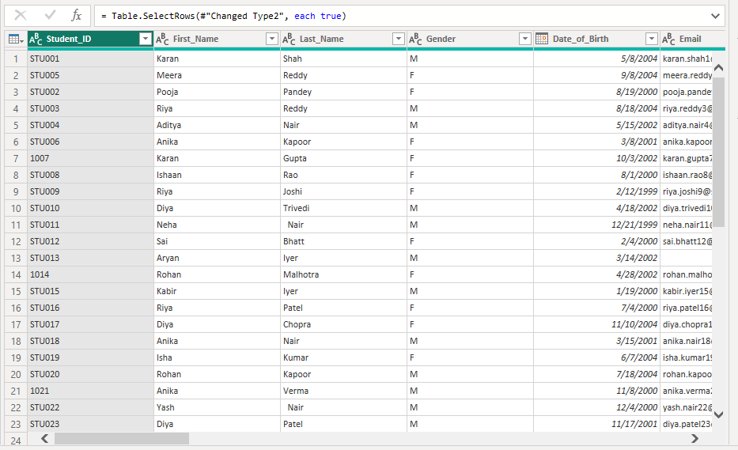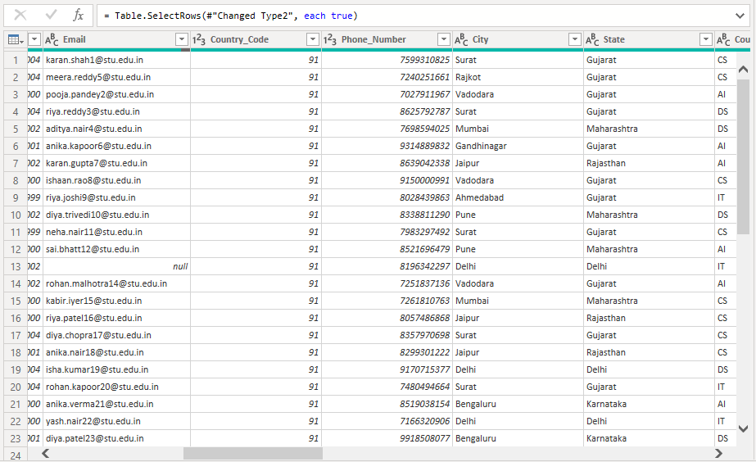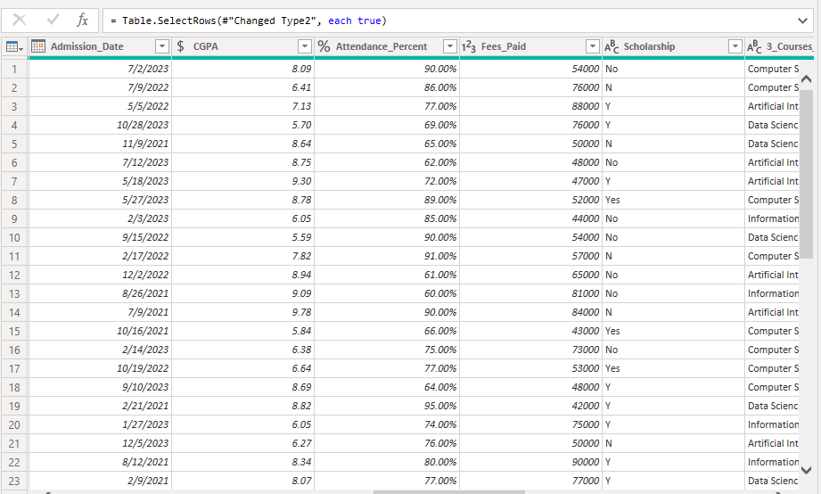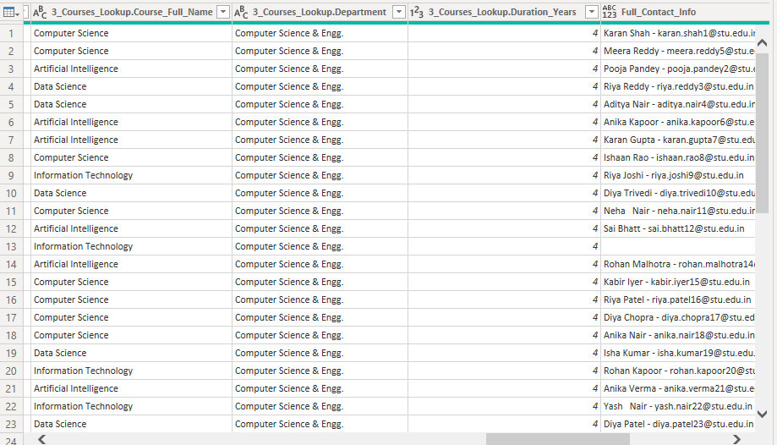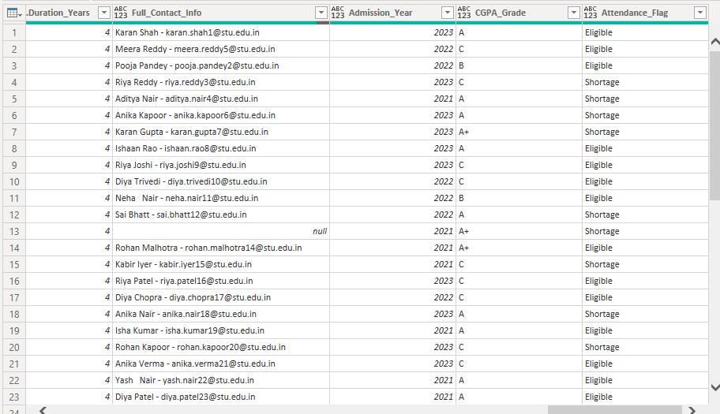

Practical 16: Merge Student and Course Information
Datasets: 1_Students_Raw, 3_Courses_Lookup
Perform the following:
- Load both datasets.
- Merge the student and course tables.
- Use Course and Course_Code as matching columns.
- Select Left Outer Join.
- Expand Course_Full_Name.
- Expand Department.
- Expand Fees_Per_Semester.
- Verify that all student records are retained.
- Rename the resulting query appropriately.
- Open Applied Steps and explain each transformation.
Expected Output: A complete student-course information table.
M-Query:
= Table.ExpandTableColumn(#"Renamed Columns", "Student_Course_Information", {"Course_Code", "Course_Full_Name", "Department", "Duration_Years", "Fees_Per_Semester"}, {"Student_Course_Information.Course_Code", "Student_Course_Information.Course_Full_Name", "Student_Course_Information.Department", "Student_Course_Information.Duration_Years", "Student_Course_Information.Fees_Per_Semester"})

In Simple English:
• Table.ExpandTableColumn → Opens/expands the merged table.
• #"Renamed Columns" → Uses the previous step as the starting table.
• "Student_Course_Information" → This is the merged column containing course information.

Practical 17: Creating a Matrix Visual with Course and Campus Analysis
Datasets: Student/Course Data + 9_Geo_Hierarchy
Create a Power BI report that performs the following:
- Use the student and course information.
- Load the geographical hierarchy.
- Create the Geo_Hierarchy.
- Create a Matrix visual.
- Add Course to the appropriate field.
- Add the geographical hierarchy.
- Display Students_Enrolled.
- Display average fees.
- Enable drill-down.
- Demonstrate:
Country → State → City → Campus
- Analyze student enrollment and fees at different geographical levels.
Expected Output: A Matrix visual showing course and campus-level student and fee analysis.

